DATE: 21.12.2018
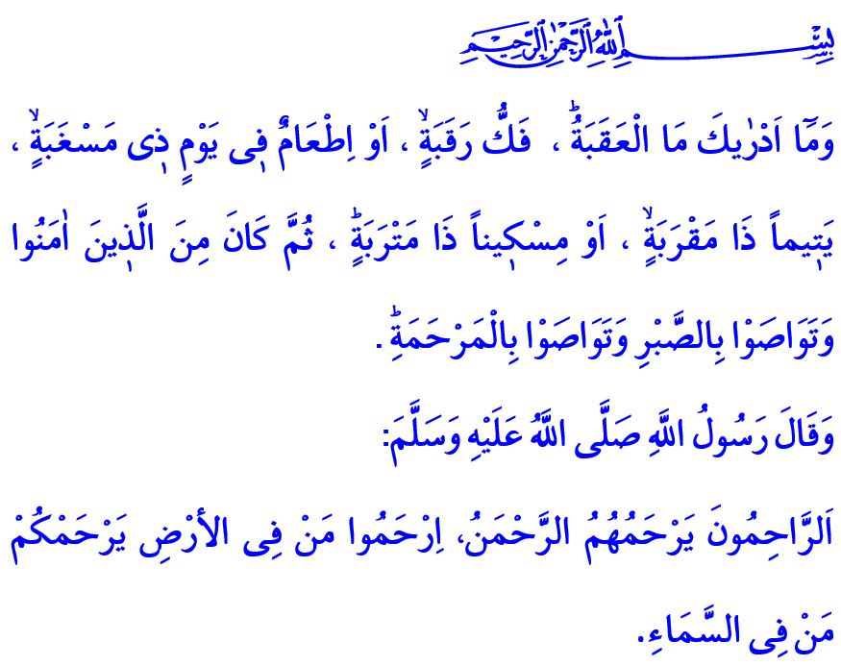DIVINE YEAST OF EXISTENCE: MERCY
Honorable Muslims!
Our Beloved Prophet’s (saw) daughter Zaynab’s (ra) child had a severe illness. Zaynab (ra) sent a message to the Messenger of Allah (saw), “My son is dying; please come to us.” The Messenger of Allah (saw) went to his daughter’s house with a group of Companions. The child was placed on his lap while his breath was irregular. Tears flowed from the eyes of the Prophet (saw). One of the Companions there asked him, “What is this, [tears in your eyes] O Allah’s Messenger?”. Upon this, our Prophet (saw) uttered the following words: “This is Mercy, which Allah has embedded in the hearts of whomever He wished of His slaves. And Allah does not bestow His Mercy except on the merciful among His servants.”
Valued Believers!
Mercy is the kindness and softness of heart. It is to be sensitive to every living creature. All the virtues such as love of the child, respect for parents, helping the elderly, the poor, patients, orphans, the homeless, and even compassion for plants and animals are all the manifestation of mercy. Mercy, the manifestation of Allah’s name “al-Rahman”, is the divine yeast of being. Mercy contains the most effective medicine for the material and spiritual diseases and the remedy for the various troubles that occupy the hearts.
Esteemed Muslims!
Our Beloved Prophet (saw) is the most splendid example that introduced compassion to the community of the jahiliyya (age of ignorance) and spread mercy in all aspects of life. To the believers, He was kind and merciful. By mercy from Allah, He was lenient with the people around Him constantly. He eased them with beautiful words. He never hurt anybody. He never left fairness and justice even while punishing, and he never persecuted anyone. He recommended that believers treat each other with love, compassion and mercy.
Valued Believers!
Today, more than ever before, humanity is in need of compassion and mercy, and conscience and justness. Countless innocent people in different corners of the world are writhing in the grip of mercilessness, and subjected to oppression and violence. Damaged by this remorselessness are not only humans, but also all other living beings, as well as our future. The Messenger of Allah (saw), on the contrary, enjoined that people treat all creatures with mercy, and said, “The Compassionate One [Allah] has mercy on those who are merciful. If you show mercy to those who are on earth, He Who is in the heaven will show mercy to you.”
Honorable Muslims!
Mercy is to not leave our parents in solitude, but stretch our wings of compassion for them. It is to be considerate, have a smiling face for our spouses, and say a couple of warm words for them. It is to be forgiving and tolerant for our children, and treat them justly.
Mercy is to caress an orphan’s head with mercy. It is to help those who are lost and in trouble. It is to share our bread with the hungry and the homeless.
Mercy is to avoid any action to not distort the balance of the world. It is to plant a sapling even it is the Doomsday. It is to provide a bowl of food and water for the hungry and thirsty animals on these cold winter days. All in all, it is to ensure that the world is a livable, safe place for all living beings.
Esteemed Believers!
Let us regard every creature created by Allah (swt) as something entrusted to us from Him, and as a precious member of the family of the universe. Let us turn mercilessness into compassion and mercy. Let us, again, instill mercy in the conscience of the time.
I would like to conclude my khutbah with the translation of the verses I recited at the beginning: “And what can make you know what is [breaking through] the difficult pass? It is the freeing of a slave. Or feeding on a day of severe hunger, an orphan of near relationship, or a needy person in misery. And then being among those who believed and advised one another to patience and advised one another to compassion.”

Bukhari, Marda (Patients), 9.
Tawbah, 9/128.
Al-i ‘Imran, 3/159.
Abi Dawud, General Behavior, 58.
Balad, 90/12-17. General Directorate of Religious Services

